(Approx. 845 words)

Kretchmar’s Korner
Don’t Buy Identity Theft Insurance
By David Kretchmar, Computer Hardware Technician, Sun City Summerlin Computer Club NV
July 2018 issue, The Gigabyte Gazette
www.scscc.club
tomburt89134 (at) cox.net

Equifax It was almost a year ago when Equifax announced that a data breach exposed the sensitive personal information of 143 million Americans. As a part of its mitigation, Equifax offered consumers a year of free credit monitoring. This offer ended in January 2018, but not to worry, for just $12.95 a month you can pay Equifax to monitor your credit reports.

This is a breathtaking bit of corporate chutzpah; first Equifax fails to secure many millions of individual’s data files (including probably yours) and now that they have proven to be untrustworthy they want to charge a monthly fee to assure you your data has not been compromised. I would just say NO!

LifeLock
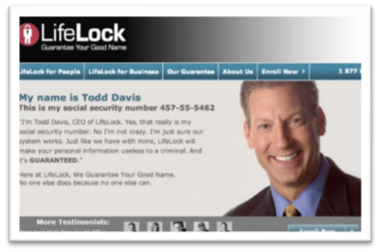
LifeLock is the most heavily advertised consumer data protection service that is offered by Symantec, a cyber security company that also provides the Norton Security Suite.

LifeLock premiered in 2005; you might remember the commercials at that time featuring LifeLock CEO Todd Davis revealing his Social Security number to the public. LifeLock failed to disclose that Davis’ identity was stolen at least 13 times during the advertising campaign. LifeLock brushed off critics, claiming that LifeLock prevented Davis’ identification from being stolen many other times, thereby proving the value of LifeLock.

LifeLock attempts to frighten consumers by saying: “Considering everything you do online, data breaches and companies that sell your information, it’s easier than ever for criminals to steal your identity. They can open accounts, buy properties, and even file tax returns in your name. There’s a new victim every two seconds, so don’t wait to get protection!”

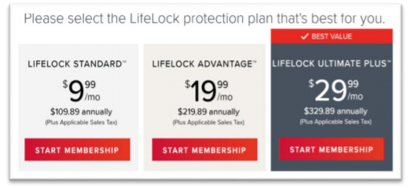
But, of course, LifeLock has the answer: Note that LifeLock does not offer a family plan; LifeLock coverage for a married couple is well over $50 a month. LifeLock does offer a 11% discount when a couple enrolls.

So, What Do You Get for Your Money?
Sadly, very little, except for a false sense of security. If you are the victim of identity theft, most institutions will absorb the cost and charge you nothing. The few consumers who do suffer monetary damages rarely lose more than $200.

Go to LifeLock’s website and you will notice that "Not all transactions at all accounts monitored" is written everywhere - on the website, as the signature to their emails, at the bottom of their site next to any disclaimer asterisk - basically giving them an out in case anything ever happens to one of your accounts.

A close reading of all of LifeLock’s service and reimbursement “guarantees” discloses so many exceptions and conditions that they are essentially worthless.

LifeLock’s Legal Woes
The Federal Trade Commission in 2015 asserted that LifeLock violated a 2010 settlement by continuing to make deceptive claims about its identity theft protection services, and by failing to take steps required to protect its users’ data. In late 2016 LifeLock paid consumer damages of over $100,000.000.00.

In documents filed with the U.S. District Court for the District of Arizona, the FTC charged that LifeLock failed to live up to its obligations under the 2010 settlement and asked the court to impose an order requiring LifeLock to provide full redress to all consumers affected by the company’s order violations.

The 2010 settlement stemmed from previous FTC allegations that LifeLock used false claims to promote its identity theft protection services. The settlement barred the company and its principals from making any further deceptive claims. It required LifeLock effectively safeguard personal data it collected from customers and required LifeLock to pay $12 million in consumer refunds.

How Can I Protect Myself?

The Equifax and LifeLock primary service is nothing you can't do much better yourself. If you think someone has stolen your identity, you can contact each of the four major credit bureaus, TransUnion, Experian, Equifax, and the newer Innovis, and place an electronic security freeze on your credit. The freeze is good until you lift it and should prevent any new accounts from being opened. A security freeze prohibits, with certain specific exceptions, the consumer reporting agency from releasing the consumer’s credit report or any information from it without the express authorization of the consumer. You can temporally lift the freeze if you want to open new accounts.
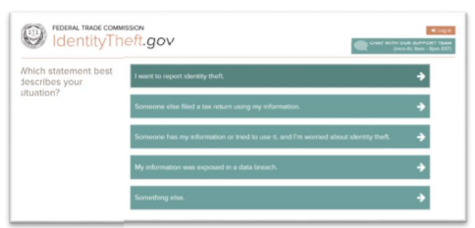
There is no charge for a security freeze if you are a victim of identity theft. To get a free security freeze you should first file a police report or (much more easily) create an Identity Theft Report at: www.identitytheft.gov/Assistant#w hat-to-do-right-away

This FTC site is easy to navigate and has some good information on what to do after an identity theft.

Conclusions and Recommendations
Don’t buy identity theft insurance from Equifax, LifeLock, or any of the other outfits selling this “protection”. The best way to protect yourself against loss is to keep an eye on your own bank, credit card and brokerage accounts and statements. Download your annual free credit reports yourself, safeguard your passwords, and skip the fees.



